INTRODUCTION

CHAPTER 1

INTRODUCTION

A Numeral Twin is a real-time digital replica of corporeal system that accurately reflects its features. The DT environment involves the formation of a clone of the tangible object to perform simulations in the virtual space. Grieves and Vickers first proposed the idea of performing simulations with a clone in a virtual environment in 2002, and National Aeronautics and Space Administration (NASA) in 2010 referred to the method as a DT. The DT concept was developed to make possible to reap the assistances of paradigms like Business 4.0 and the Cyberspace of Things (IIOT). The clue is make every product or process-related data source and control interface description accessible through a single interface for automatic communication establishment and auto-discovery. Without specific knowledge of each component, developers and engineers can determine, design, and construct the required interfaces, integrations, and communication links by analyzing the DTs of the incorporated components. The devices may eventually to locate and interconnect with 1 & another without need for human engineer to stand in between them. With the assistance of DTs, this kind of auto-discovery and auto-established communication may eventually make IOT more scalable for currently unimaginable applications. The numerous fields in which DT technology is being studied are manufacturing, construction, healthcare, and space industries. IOT and versatile gadgets have as of late been included to the DT technology’s application extend. For occasion independent driving can be accomplished in a vehicular environment, and exact and nitty gritty inaccessible therapeutic treatment can be carried out in a restorative environment.

1.1 Project Description
Cloud computing is the foremost attainable approach for actualizing DT administration since it has monstrous preferences. It provides on-demand services, computing resources, ubiquitous network access, etc., making it suitable for the next-generation information technology architecture. In cloud assisted DT environments, the data owners generate data from physical assets and disseminate it to the cloud server, simulating DT in virtual space and sharing the replication results with the owner. At same time, user can access the data upon request. However, putting DT technology into practice faces several obstacles. The biggest challenge is finding a secure way to share simulation and real-time data. Serious privacy implications are to be faced if the sensitive information transmitted by the data owner gets held by the adversary. Evidently, the below-illustrated points are necessary for the deployment of DT environment: (a) There is a strong urge to develop a secure medium for efficiently sharing the transmitted data. (b) There must be a procedure for validating the transmitted data; that is, verification of data integrity is required. (c) Security prerequisites such as untraced ability, anonymity, and confidentiality should be guaranteed.

To achieve the aforementioned security prerequisites, we need a locked and privacy preserving authentication protocol employing the aids of block chain technology. With Block chain, the data owner or user who utilizes data is allowed to verify the truth of the data. Users may readily validate the requested data using a Merkle hash tree. The framework proposed in this paper utilizes a cloud server to store the DT data and block chain the data hash values, enabling the workers to verify the truth of received data. Furthermore, the log transactions of shared data among the user-server are uploaded to the block chain.
A. Motivation And Contributions: Several authentication mechanisms are introduced in the literature however, the majority of them cannot withstand various security assaults. For instance, many two-factor-based protocols cannot facilitate forward secrecy and user anonymity properties; many cannot withstand identity and password guessing attacks. Similarly, some cannot withstand user and server impersonation attacks, and only a small number can be validated using ROR Model and BAN logic. Furthermore, most authentication mechanisms are designed employing traditional public cryptosystems and identity-based cryptosystems. However, these cryptosystems have some loopholes.

The loopholes in the paradigms created using the public cryptosystem and the identity-based cryptosystem are the complex certificate management, storage, and key escrow problem, respectively. Since certificate less cryptosystems offer the best solution to the aforementioned issues, many certificate less paradigms have been proposed to overcome these vulnerabilities. In this paradigm, a third party is accountable for reckoning the partial private keys of users, while the user itself reckons the private key by employing the partial private key. Utilization of elliptic curve cryptography (ECC) in the system upsurges the computational efficiency. Hence, we have adopted the certificate less authentication scheme for the DT environment utilizing block chain technology. We could summarize our contributions as follows:

- Firstly, we review and cryptanalysis the scheme proposed by Son et al. [7] and identify that the scheme is susceptible to impersonation attacks, password guessing attacks, anonymity, and untraced ability attacks. Besides, it not support mutual substantiation and session key agreement.
- We design a ‘‘secure three-factor privacy-preserving authentication scheme for the DT environment’’ by utilizing block chain technology and ‘‘elliptic curve cryptography (ECC)’’ to realize secure communication among legitimate users and conquer security flaws.
- The suggested framework’s informal analysis ensures that the protocol is resilient to various security assaults. Using the ROR model and BAN logic, we also demonstrate that the proposed scheme can assure ‘‘mutual authentication’’ and ‘‘session key security’’.
- The computational and communication efficiency of the work is demonstrated by analyzing the presented work with the pre-existing authentication schemes.

B. Structure Of The Paper: The remaining structure of the paper is arranged as follows. Section II presents the related work. Section III is preliminaries which includes the threat model, biohashing function, and the security model. Section IV includes the review of Son et al.’s scheme, while Section V discusses the cryptanalysis of Son et al.’s scheme. Section VI contains the proposed scheme to guarantee secure communication, whereas the security analysis of the proposed work containing informal analysis, BAN Logic and ROR model is given Section VII. Section VIII includes a detailed comparative study of proposed work with the existing competing schemes, and in the last, Section IX we have concluded our work.

1.2 Company Profile:

About the organization

Web BLITZ Package Pvt Ltd is The Global Development Organization's internet brand. Web BLITZ Systems was founded 2010 in Bengaluru, and we have been creating arrangements to complicated challenges for over a decade. We are little process adaptable team, and each member has a specific function in taking your digital design plan from ordinary to amazing. We consume created and hurled over 100 websites and are actively working on India and client projects. Our trained professionals worked hard with sincerity to generate unique ideas and deliver the proper solutions on time as per the client's requirements. We've occupied with hundreds of patrons from idea to completion over the last nine years, and we're always delighted about chance to collaborate with us.

Raghavendra G, the company's CEO, was a proficient in technological enrichment. The firm was founded from 2010 as an IT growth business in Bangalore, India, with a single goal and approach: to provide excellent jobs for our clients.
Future Future Pvt Ltd offers a well-designed and efficient strategy to assisting businesses in meeting global competitiveness through information technology. Their offering of services is only the jerk of their engagement with our consumer.

Mission

Web BLITZ Software Pvt Ltd, formed in 2010, is the ecosphere pioneer in work environment efficiency computer program items. They supply software that helps process-driven enterprises improve operational efficiency, expedite digital adaptation, and maximize regulatory devotion. They realize this by evolving explanations that benefit our clients decrease the risks, waste, and delays that come with human-driven operations.
• Raghavendra, who G. is the founder and CEO of Web BLITZ Solutions Pvt. Ltd.

Objectives
We keep adding new feature to your website up-to date and we want you to attention on your occupational not website maintenance! marketing, a thriving social media platform, and governance of reputation. The targets listed above are only samples; you may design entirely other goals to accomplish the same ends. Nor are they restricted. For example, even though "building trust" was discussed under "Become a trustworthy locate," building trust is equally essential to boosting selling.
Course Syllabus to be covered:
Qualifications: There are no qualifications for learning Python, although having a basic understanding of programming language concepts such as what a circle is, what else does, how managers are used, and so on will be beneficial. If you understand the fundamentals of all programming languages, you will be able to learn Python quickly.
1) Learning Factors.
Python has a quantity of features, which are listed below.
2) Easy To Pick Up And Use.
Python is simple to learn or use. It is a developer-friendly, high-level programming language.
3) Python's expressive language makes it easier to learn and read.
4) Transcribed Speech
Py is a language with interpreted syntax, which means that the interpreter produces the code line.

LITERATURE SURVEY

CHAPTER 2

LITERATURE SURVEY

2.1 Existing and Proposed System

Existing System

(IIoT) applications, the protocol designed by Sasikumar et al. [36] integrates DT with a distributed network employing block chain.
In instruction to deliver high-quality services for the IoT, such a data privacy and security, this study suggests a Proof of Authority (PoA) trust mechanism based on blockchain technology. Similar to this, Wang et al. suggested a sustainable DT management architecture for an IoT environment utilizing blockchain to enable network decentralization and efficient data transmission.

Grover et al. highlighted the security vulnerabilities of the protocol designed by Wazid et al. Also, they proposed an enhanced mechanism for smart grid environments, which was analyzed by using the Pro Verif tool. Kaur and Kumar devised a two-factor user authentication framework for smart homes. They illustrated their scheme to be more efficient and highlighted the security vulnerabilities of the Shuai et al. scheme.

Similarly, the security flaws of Chen et al. work is illuminated by Wu et al. They further proved the superiority of their protocol by comparing it with similar pre-existing protocols. In telecare restorative data systems(TMIS), Khatoon et al. built up a key between clients and servers. They appeared that their convention may guarantee a few security functionalities with superior productivity. However, their scheme offers no mechanism for data verification and is susceptible to Known session-specific temporary information attack. Sengupta et al. also developed an authentication framework for cyber-physical systems utilizing ECC and bilinear pairing. However, this framework was later cryptanalyzed to show that it did not successfully preserve user anonymity. All these aforementioned procedures were developed for environments comparable to DT, but do not handle DT environments.

Disadvantages
In an existing system, two-factor-based protocols cannot facilitate forward secrecy and user anonymity properties; many cannot withstand identity and password guessing attacks. Similarly, some cannot withstand user and server impersonation attacks, and only a small number can be validated using ROR Model and BAN logic. Furthermore, most authentication mechanisms are designed employing traditional public cryptosystems and identity-based cryptosystems.
However, these cryptosystems have some loopholes. The loopholes in the paradigms created using the public cryptosystem and the identity-based cryptosystem are the complex certificate management, storage, and key escrow problem, respectively.

2.2 Proposed Methodology

Since certificate less cryptosystems offer the best solution to the aforementioned issues, many certificateless paradigms have been proposed to overcome these vulnerabilities. In this paradigm, a third party is accountable for reckoning the partial private keys of users, while the user itself reckons the private key by employing the partial private key. Utilization of elliptic curve cryptography (ECC) in the system upsurges the computational efficiency. Hence, we have adopted the certificateless authentication scheme for the DT environment utilizing blockchain technology.

We could summarize our contributions as follows:

- Firstly, we review and cryptanalysis the scheme proposed by Son et al. [7] and identify that the scheme is susceptible to impersonation attacks, password guessing attacks, anonymity, and untraceability attacks. Besides, session key agreement.
- We design a ‘‘secure three-factor privacy-preserving authentication scheme for the DT environment’’ by utilizing blockchain technology and ‘‘elliptic curve cryptography (ECC)’’to realize secure communication among legitimate users and conquer security flaws.
- The suggested framework’s informal analysis ensures that the protocol is resilient to various security assaults. Using the ROR model [17] and BAN logic [18], we also demonstrate that the proposed scheme can assure ‘‘mutual authentication’’ and ‘‘session key security’’.
- The computational and communication efficiency of the work is demonstrated by analyzing the presented work with the pre-existing authentication schemes.

Advantages

A malicious adversary can replay, insert, eavesdrop, modify and delete transmitted messages sent through an open channel.
- An adversary can use the ‘‘power-analysis attacks to extract the secret credentials stored on a stolen user’s smart card or mobile device’’.
- During the registration phase, the adversary can capture or tamper smart device. As a result, an challenger is able obtain the secret credentials from the device’s memory and can attempt various other security attacks.
- Adversary could be a registered user or a malicious insider or vice-versa.
- Adversary can simultaneously perform offline identity and password guessing attacks. As a result, the opponent able to simultaneously determine the genuine user’s identity and password.

2.3 Feasibility study
This arrange includes assessing the project's practicality and presenting and displaying a commerce arrange a really fundamental venture format and taken a toll projections. A feasibility assessment of the proposed system will be carried out during system analysis. This is to ensure that the company is not burdened by the proposed remedy. Comprehending the main system specifications is essential for conducting a feasibility study.
Three main factors are considered in feasibility analysis:
• Realistic Cost The technical viability
• Viability in society
2.3.1 Economical Feasibility
This explore is animation directed to determine the fiscal effect that the framework might have on the company. The business has a limited quantity of funds to invest in classification explore and change. Expenses must be justified. As a outcome, the produced system remained below budget, thanks to the fact that the majority of the technologies employed are publicly accessible. Only bespoke goods needed to be ordered.

2.3.2 Technical Feasibility
This research is conducted to regulate the system's mechanical feasibility, or needs. Any organization planned must not place a significant draining on the existing technological resources. This will place a significant strain on the existing technological resources. This will result in excessive demands on the client. The classification that is bent must have a low requirement since implementation requires only little or no adjustments.

2.3.3 Social Feasibility
The resolution of the examine is to regulate the level of system acceptability by the worker. This protections the process of preparing the to operate the technology effectively. The manipulator ought not sensation frightened by the system, but rather embrace it need. Amount of user acceptance is primarily determined by the means used to instruct and familiarize the employer with the system. His poise must be built up so that he may offer constructive feedback, which is appreciated given that he is the system's final user.

2.4 Tools and Technologies Used
- Java:
  - Overview: Java widely-used programming language known for its platform independence and versatility.
  - Usage in Projects: In web development, Java is often used on the server-side to create dynamic web applications. This can involve building business logic, handling requests from clients (browsers), and interacting with databases.
  - Frameworks and Libraries: Java frameworks like Spring MVC, Java Server Faces (JSF), or Play Framework are commonly used for web development to streamline development tasks and provide robust features.
- HTML (HyperText Markup Language):
  - Overview: HTML is the average markup philological used to create web pages. It defines the structure of web content using elements and attributes.
  - Usage in Projects: HTML forms the backbone of web pages by defining the content and structure that users see and interact with. It is essential for creating the visual and functional plan of a website.

- CSS (Cascading Style Sheets):
  - Overview: CSS is a style page verbal used for recitation the presentation of a article written in HTML.
  - Usage in Projects: CSS is used to controller the visual layout of HTML elements. It defines how HTML fundamentals should be displayed, including aspects like fonts, colors, margins, and positioning. CSS enables developers to create attractive and responsive web designs.
- Tomcat:
  - Overview: Apache Tomcat is an open source web attendant and servlet container that is second hand to serve Java-based web applications.
  - Usage in Projects: Tomcat is particularly suited for deploying Java web applications. It provides the environment needed to run servlets and JavaServer Pages (JSP), which are server-side technologies for generating dynamic web content. Tomcat acts as the middleman between the user's browser and your Java application, handling HTTP requests and serving responses.
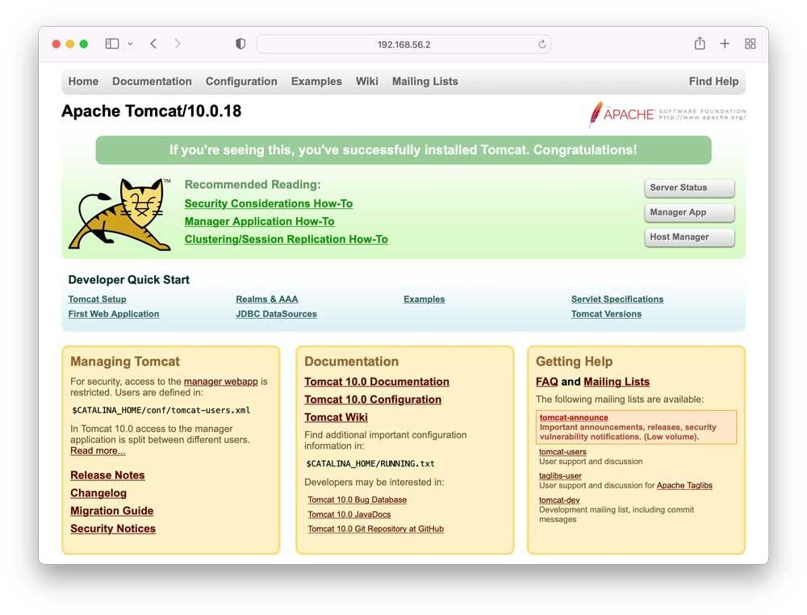
Fig 2.1 Apache tomcat10.0.18

Integration in a Project:

- Frontend (HTML/CSS): HTML and CSS are utilized to form the frontend client interface (UI) of your web application. HTML chararacterizes the structure of your web pages, whereas CSS styles them to supply aoutwardly engaging and responsive format.

- Backend (Java with Tomcat): Java with Tomcat handles the backend logic and server-side processing. You write Java code to handle business logic, connect to databases, and process requests from users. Tomcat serves as the runtime environment for your Java web application, overseeing HTTP demands, servlets, and JSPs.

- Interaction: The frontend (HTML/CSS) communicates with the backend (Java with Tomcat) through HTTP requests. For example, when a user submits a form on an HTML page, the form data is sent to the Tomcat server. Java code running on Tomcat processes this data, performs necessary operations (like database queries or computations), and generates a response, which is then sent back to the user's browser to update the HTML page accordingly.
In summary, Java, HTML, CSS, and Tomcat are integral components of a web development stack. Java and Tomcat handle the server-side processing and business logic, while HTML and CSS define the frontend UI and user experience. Together, they enable you to build robust, interactive, and dynamic web applications

SOFTWARE REQUIREMENT SPECIFICATION

CHAPTER 3

SOFTWARE REQUIREMENT SPECIFICATION

3.1 SYSTEM REQUIREMENTS

H/W System Configuration:
- Processor - Pentium –IV
- RAM - 4 GB (min)
- Hard Disk - 20 GB
- Key Board - Standard Windows Keyboard
- Mouse - Two or Three Button Mouse
- Monitor - SVGA

Software Requirements:
- Operating System - Windows XP
- Coding Language - Java/J2EE(JSP,Servlet)
- Front End - J2EE
- Back End - MySQL

3.2 Introduction

The Software Requirement Specification (SRS) outlines the requirements for developing an Effective Privacy-Preserving Blockchain-Assisted Security Protocol for a Cloud-Based Digital Twin Environment. This document serves as a blueprint for developers, stakeholders, and testers to understand the functionality, constraints, and performance expectations system.

Purpose
The resolution this project is enhance security and privacy in cloud-based digital twin environments using blockchain technology. This involves implementing a robust security protocol that ensures confidentiality, integrity, and availability of data while leveraging blockchain for decentralized trust management.

Scope
The scope of the project includes:
- Designing and implementing a privacy-preserving security protocol.
- Integrating blockchain technology for secure data exchange and validation.
- Supporting cloud-based digital twin environments across various industries.
- Ensuring compliance with relevant security standards and regulations.

3.3 Functional Requirements

Authentication and Authorization
- Users must authenticate securely before accessing digital twin data.
- Role-based access control (RBAC) to manage permissions based on user roles.
- Support for multi-factor authentication (MFA) to enhance security.

Data Privacy and Encryption
- End-to-end encryption of data transmitted between digital twins and cloud servers.
- Anonymization and pseudonymization techniques to protect user identities.

Blockchain Integration
- Integration with blockchain for decentralized identity management and access control.
- Smart contracts to enforce security policies and automate transactions securely.

Audit and Logging
- Logging of all access and modification attempts to digital twin data.
- Audit trails to track changes and ensure data integrity.

Compliance and Standards
- Compliance with GDPR, HIPAA, or other relevant data protection regulations.
- Implementation of security best practices and standards (e.g., ISO 27001).

3.4 Non-Functional Requirements

Performance
- Response time for authentication and data access should not exceed 500ms.
- Scalability to handle concurrent users and large volumes of data.

Security
- Encryption keys must be stored securely and rotated periodically.
- Regular security audits and vulnerability assessments.

Reliability
- System uptime of at least 99.99% to ensure continuous availability.
- Fault tolerance to handle server failures or network interruptions.

Usability
- Intuitive user interface for easy navigation and minimal training.

Maintainability
- Modular and documented codebase to facilitate future enhancements.
- Version control and configuration management for code and infrastructure.

System Architecture
- Components: Frontend UI, Backend servers, Blockchain network (e.g., Ethereum), Database.
- Technologies: Java for backend development, HTML/CSS/JavaScript for frontend, Solidity for smart contracts.

SYSTEM DESIGN

CHAPTER 4

SYSTEM DESIGN
The purpose of System Design in software development is to translate the requirements specified in the Software Requirements Specification (SRS) into a blueprint that outlines how the system will be structured and organized. It serves several key purposes:

4.1 Detailed Planning and Organization
System Design provides a detailed plan for how the software system will be structured, including:
- Architectural Design: Defining the total building of the system, such as choosing between monolithic, microservices, or other architectural patterns.
- Component Design: Breaking down the system into smaller components/modules and defining their interactions and dependencies.

Database Design: Designing The relational database structure includes tables, interactions, and content. storage strategies.

Implementation Guidelines
System Design serves as a guideline for developers by:
- Defining Interfaces: Specifying interfaces between different system components, modules, or services to ensure seamless integration during implementation.
- Detailing Algorithms and Data Structures: Describing algorithms and data structures needed to implement specific functionalities efficiently.
- Performance and Scalability Considerations System Design addresses:
  - Performance Optimization: Planning for efficient resource utilization, minimizing response times, and optimizing data access.
- Scalability: Designing the system to handle increased loads, traffic, and data volumes as the user base grows.
  - Reliability and Resilience System Design focuses on:
- Fault Tolerance: Designing mechanisms to handle system failures gracefully, ensuring minimal impact on users.
- Backup and Recovery: Planning for facts backup strategies and recovery procedures to maintain system reliability.

4.2 Architecture
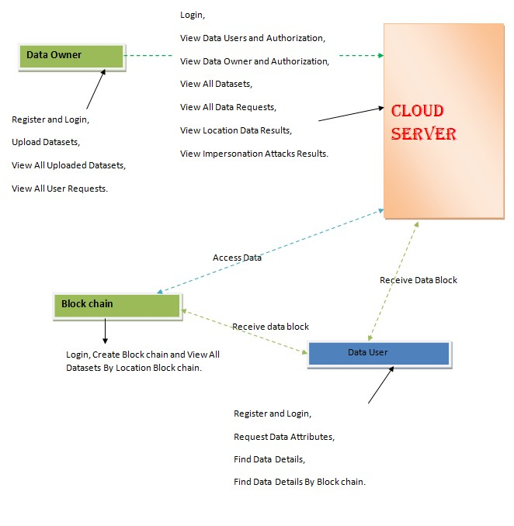
Fig 4.2: System architecture

4.2.2 Data Flow Diagram

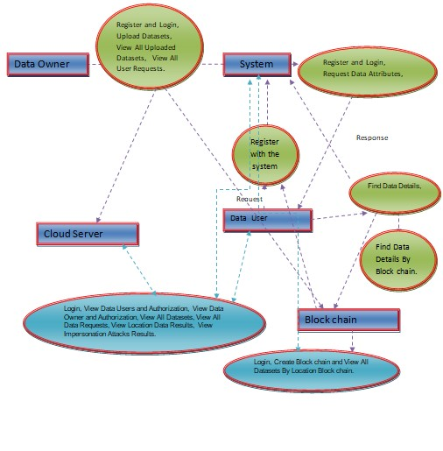
Fig 4.2: System Process

- Data Generation and Capture:
- Source: Physical assets or systems that have digital twins in the cloud environment.
- Process: Sensors, IoT devices, or other data sources generate real-time data about the physical assets.
- Flow: This data is captured and sent to the cloud-based digital twin environment where it is stored and processed.

- Data Storage and Management:
  - Storage: Data from digital twins is stored in cloud databases or storage systems.
  - Management: Metadata about digital twins, such as configuration settings and access controls, is managed securely.
  - Flow: Data is organized and prepared for further processing and analysis.
- Data Processing and Analysis:
  - Processing: Algorithms and analytics tools process the data to derive insights or monitor the behavior of physical assets.
  - Analysis: Data scientists or automated systems analyze the processed data to detect anomalies or trends.
  - Flow: Processed data and analysis results are stored back in the cloud environment.

- Data Transmission and Blockchain Integration:
  - Transmission: Processed data and analysis results are transmitted securely over the network.
  - Blockchain Integration: Before transmission, data integrity checks and cryptographic techniques ensure data security and privacy.
  - Flow: The use of bitcoin facilitates safe data verification and interchange among many organizations across industries digital twin environment.

- Blockchain-Assisted Security Protocol:
  - Protocol Implementation: Smart contracts or blockchain transactions enforce security policies.
  - Decentralized Identity Management: Blockchain manages identities and access control, ensuring only authorized parties can access data.
  - Flow: Security protocols ensure confidentiality, integrity, and availability of data within the digital twin environment.

- Privacy-Preserving Techniques:
  - Anonymization and Encryption: Techniques like anonymization and encryption are applied to protect sensitive data.
  - User Consent and Permissions: Privacy controls ensure that data is only accessible to authorized users.
  - Flow: Data is anonymized or encrypted before being stored or transmitted to preserve user privacy.

- Access and Usage:
  - Authorized Access: Users with appropriate permissions access digital twin data for monitoring, analysis, or decision-making.
  - Audit Trails: Logs record access attempts and modifications to ensure accountability and traceability.
  - Flow: Secure get to instrument and review trails keep up information judgment and security throughout its lifecycle.

4.2.3 Flow Chart: Data Owner

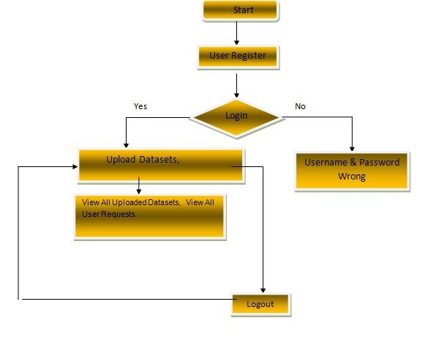

Fig 4.3: Data owner

4.2.4 Flow Chart: Data User

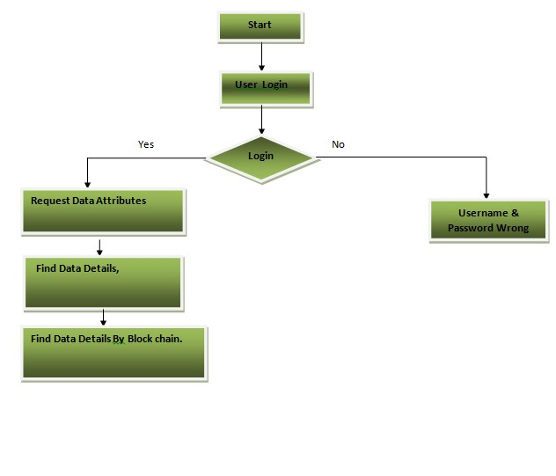
Fig 4.4: Data User

4.2.5 Flow Chart: Cloud Server
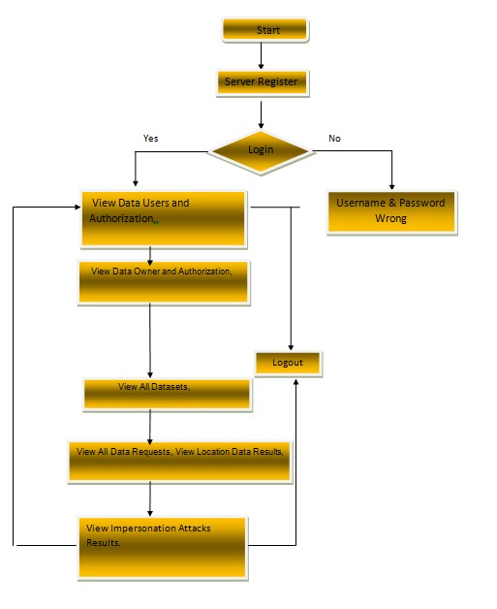

Fig 4.5: Cloud Server

4.2.6 Flow Chart: Block chain
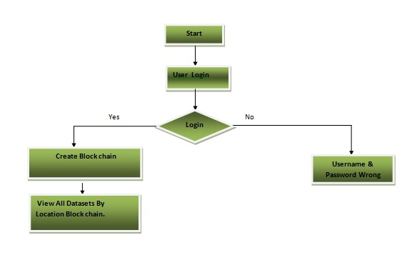
Fig 4.6: Cloud Server

4.2.7 Use case diagram
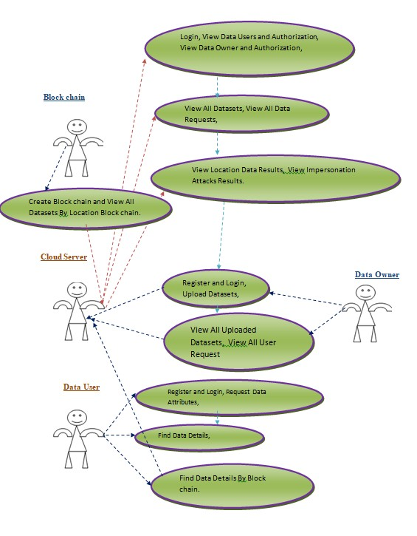

Fig 4.7: Use case diagram

SOFTWARE TESTING

CHAPTER 5

SOFTWARE TESTING

5.1 Introduction

The box of checking is recognize mistakes. Testing is the practice of attempting to identify every possible flaw or vulnerability in an output. It allows you to examine the functionality of sections, sub-assemblies, meetings, and/or a final produce. Package taxing agreements that the structure satisfies consumer demands and prepares not break unexpectedly. There are several sorts of tests. Apiece test type focuses on a distinct testing need.

5.2 Types Of Tests

The method of developing scenarios for unit testing verifies that the essential software logic is operating as intended and that its inputs create valid outputs. Every decision branch and insider code flow must be checked. It is the examination of particular software elements inside the bid. It occurs after an discrete element has been done but before to integration. This is an invasive physical test that needs data of the structure's design. Unit tests run simple component-level tests on a given occupational course, claim, or organization configuration. Unit tests guarantee that each individual route of an operation course obeys to the stated riders and provides explicit inputs and anticipated upshots.

5.2.1 Integration Testing

Assessments of integration are used to evaluate whether integrated software components function as a single sequencer. Tough is event-driven and attentions on the straightforward consequence of canopies or variables. Mixing tests verify that, although the individual components were satisfied, as seen by successful unit evaluations, the combination of features is correct and consistent. Mixing testing is primarily designed to representation issues that befall after the integration of mechanisms.

5.2.2 Functional Test

Function testing provide methodical proof that features under evaluation are available in compliance with both technology and economic standards. demands, system paperwork, and user manuals.
Functional testing focuses on these particular items:
acceptable Input: The specified classifications of acceptable input must be recognized.
Invalid Input: The detected classifications of improper input obligation be discarded.
Functions: The indicated functions are be engaged.
Output: The indicated kinds of applications outcomes must be exercised.
Systems/processes: Interfacing procedures or systems must be activated.
Practical tests are organized and prepared with a focus on requirements, vital purposes, and particular test cases. Furthermore, thorough reporting of finding occupational course flows, data fields, established measures, and ensuing developments duty be evaluated for taxing. Already the functional assessment is finished, new tests are found, and the true value is determined.

5.2.3 System Test

Difficult the organization promises that all incorporated software systems's requirements are met. It verifies that a configuration yields reliable and consistent results. Configuration-oriented integrated system exams are part of organization difficult. Process definitions and flows aid as the basis for system testing, which places a focus on pre-established course links & connecting facts.
5.2.4 White Box Testing

In white box evaluation, the participant has access to the underlying structures, framework, and syntax of the application, or at least, they know what it is intended to do. It serves an objective. It's used for testing hidden areas.
from a level of the black box.

5.2.5 Black Box Testing

Black Box Software is tested through the process of testing, which involves not knowing the inner functions, order, or syntax of the module being tested. Similar to other forms of testing, black box tests also need to be grounded in one final record, such a requirements document or specification. This type of testing is effective when the software under test is viewed as a "black box."It's impossible to "see" within. The test responds to signals and takes in inputs with no evaluating how the software operates.

5.2.6 Unit Testing:
Unit testing is often performed portion of a merged code nor unit test stage thru the package development lifecycle, while programming and element difficult may be performed separately.

Test strategy and approach
Arena inspections will be done manually, and functional evaluations will be documented in detail.
Test goals include ensuring all turf entrances operate properly.
• Activate pages using the known link.
• Is entering screen, messages, and answers should not delayed. Test features include ensuring accurate entry format, preventing duplicate entries, and ensuring all links lead to the proper page.

5.2.7 Integration Testing
Program combination analyzing is the process of incrementally testing multiple software parts that are integrated on one system in order to induce failures due to interface issues. The integration test's purpose is guarantee elements or computer software claims, such as those in a software system or, on a higher level, company-level computer programs, interact correctly.

5.2.8 Acceptance Testing
User Taking Difficult is an important component of project that demands active engagement from the end operator. It also guarantees that system satisfies its functional specifications.
Test Results: All of the test scenarios described above were successful. There were no faults found.

SYSTEM TESTING

5.3 TESTING METHODOLOGIES

The subsequent are the Difficult Methodologies:
- Unit Testing.
- Integration Testing.
- User Getting Testing.
- Output Testing.
- Validation Testing.

5.3.1 Unit Testing
Unit testing concentrates verification efforts on the most tiny unit package design, known as the module. Unit testing runs particular pathways across a module's control structure to achieve full coverage or optimal error discovery. This examines respectively module individually to guarantee that works correctly as a unit. As a result, the name is Unit Testing.
Throughout this testing, each component is tested independently, and its components and interconnections are checked for compliance with the design specifications. All grave dispensation paths are evaluated for expected outcomes. All error-handling pathways are also checked.

5.3.2 Integration Testing
Integrated for covers challenges related to the combined concerns of testing and program creation. After the sequencer is incorporated, a series of high-level tests are performed. The major goal of difficult way is to gather unit tested sections and create an architecture for the program that is well-defined by philosophy.
The following are the types of Integration Testing:

- Top Down Integration
This technique to building the program framework is gradual in nature. Starting with the primary program module and working down the control hierarchy, modules are integrated. The primary program module's subordinate modules are integrated into the framework either in a depth-first or breadth-first fashion.This approach involves testing the software starting with the foremost segment and replacing separate stubs as the test moves downhill.

2. Bottom-up Integration
With this approach, the components at the nethermost of the sequencer hierarchy are where the building and testing process starts. Because the modules work together form the bottom up, stubs are not necessary because the processing needed for modules subservient to a convinced level is continuously accessible.

The bottom up integration strategy may be implemented with the succeeding steps:
• The basic components are grouped together to form clusters that each carry out a particular software sub-function.
• To coordinate the effort & productivity of test cases, a driver, or control software, is built.
• A test is run on the cluster.
• Clusters are merged and drivers are eliminated as the program structure rises.
• The bottom-up methods test each module separately before integrating them with a core module as well as functional testing them.
5.4 OTHER TESTING METHODOLOGIES
User Acceptance Testing:
The most imperative element in any system's performance is user acceptance. While the system is being developed, it is continuously evaluated user tolerability by staying in continual communication with potential users and making necessary modifications. Even somebody who is unfamiliar with the arrangement may eagerly understand the user edge as to the classification's pleasant design.
Output Testing:
The suggested system's output must be tested when the validation testing is finished, as no system can be helpful if it cannot offer the necessary output in the fitting format. By asking users what format they need, you may test the outputs that the arrangement considering producing or displaying. As a result, there are two ways to think about the output format: one is on screen, and the other is printed.
Validation Checking: The subsequent fields are subject to validation tests.
Text Field:
Only a character count that is below or equal to the text field's size may be entered. In certain tables, the contents of the fields are alphabetical, while in others, they are alphanumeric. An error message is always displayed upon incorrect entry.
Numerical Field: Only numbers between 0 and 9 may be entered in this field. Any character entered causes an error message to appear. Each element is observed for correctness and its required functionality. Test turns are showed on every module using sample data. The separately tested elements are combined into one cohesive system. Testing entails seriatim the package with actual data, from which any program defects are deduced.

Preparation of Test Data
The testing mentioned above is done using several kinds of exam information. Preparing the test numbers is crucial to testing the system. The established of quiz data is used to test the mechanism that is being looked at. When the equipment is tested utilizing test results, problems are discovered once and then are corrected utilizing the testing procedures declared upstairs. The adjustments are also recorded for later use.

Using Live Test Data:
The exam data are really taken out of organization files are called live exam statistics. Computer operator or analysts frequently ask users to enter a gathering of data from their everyday activities after a system is largely built. Subsequently, the systems specialist employs this data to do a partial system test. In other cases, gathering of real-time data is taken from files by programmers or analysts, who then enter it them selves.Acquiring enough real-time data to do exhaustive testing is a challenging task. Furthermore, even if the data is realistic and will demonstrate how the system functions for a typical processing requirement—assuming that the actual data provided are, in fact, typical—it often prepares not test all conceivable groupings or formats.

Using Artificial Test Data:
Since artificial test data may established test any combination of formats and values, they are prepared only for testing purposes. Put otherwise, the knowledge systems department's material generating utility software can swiftly produce artificial data, which allows for the testing of each login and control channels through the software.
Artificial test data created by anyone other than the programmers is used by the most successful test programs. Frequently, a separate group of testers creates a testing strategy based on the system requirements.The "Virtual Public Network" package was approved since it satisfies every condition listed in the software need specification.
User Training
Anytime a fresh system is created, users must receive user training to inform them of how it functions and enable the people for whom it was intended to be used to utilize it effectively. For this reason, potential users were revealed how plan typically operates. Its action is modest to realize, and since those with strong computer skills are the intended audience, using the system is a breeze.

Maintenance
Fixing coding and design flaws is only one of the many tasks covered by this. We have more precisely In order to reduce the total demand for upkeep, the user's demands were stated during the software construction phase. Depending on the requirements, it has been made to try to satisfy as many of the criteria as possible. Future technological advancements could make it feasible to add a lot more functions, depending on what's needed. Simple, understandable coding and design will facilitate simpler upkeep.

Testing Strategy :
A system testing strategy combines design methodologies and system exam belongings into a methodically organized sequence of actions that centrals to the successful creation of package. The difficult approach must include preparing for tests, test instance enterprise, test accomplishment, and the data assembly and assessment that follows.Software testing techniques must billet low-level tests compulsory to authenticate that a trivial computer sequence has been written correctly, as glowing as high-level quizzes that verify important system operations counter to user foods. Software testing is an essential part of reliability guarantee and is the last evaluation of demand design and code. Testing offerings an motivating difference for the package. As a result, several experiments are conducted on the suggested system prior .

System Testing:
After software is verified, it has shared with other classification components, such as hardware, personnel, and databases. System testing confirms that every component is in working order and that general system performance is attained. It also looks for variations in the system's existings

Unit Testing:

Various components are confirmed in unit testing by comparing them to riders created through the module's creation. The purpose of unit difficult is to verify the code generated thru the software design stage, which is why it is crucial the inner logic of modules. To find mistakes inside the module boundaries, critical Conrail paths are appraised using the comprehensive use the layout statement as an example. This examination is completed. in the actual programming phase. Every component was resolute to be functioning successfully in rapports of producing the desired results from the element during this kind of taxing progression.
The most recent developments in technology will be taking into account eventually.Countless the connectivity system's components will be generic in nature the technical build-up.

IMPLEMENTATION

CHAPTER 6

IMPLEMENTATION

6.1 Screenshots

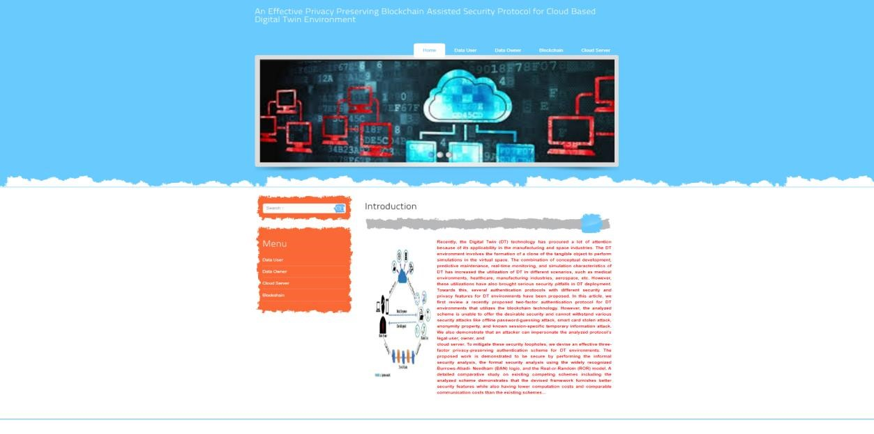

Fig 6.1: Home Page

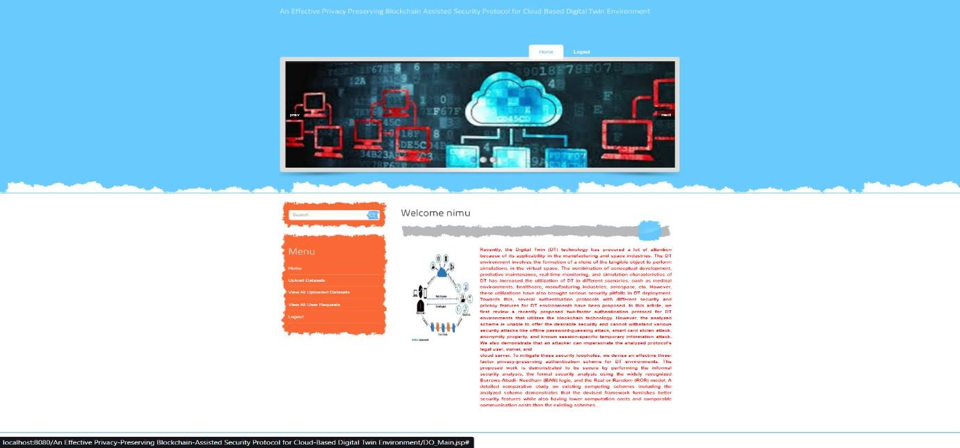

Fig 6.2: Data owner login page

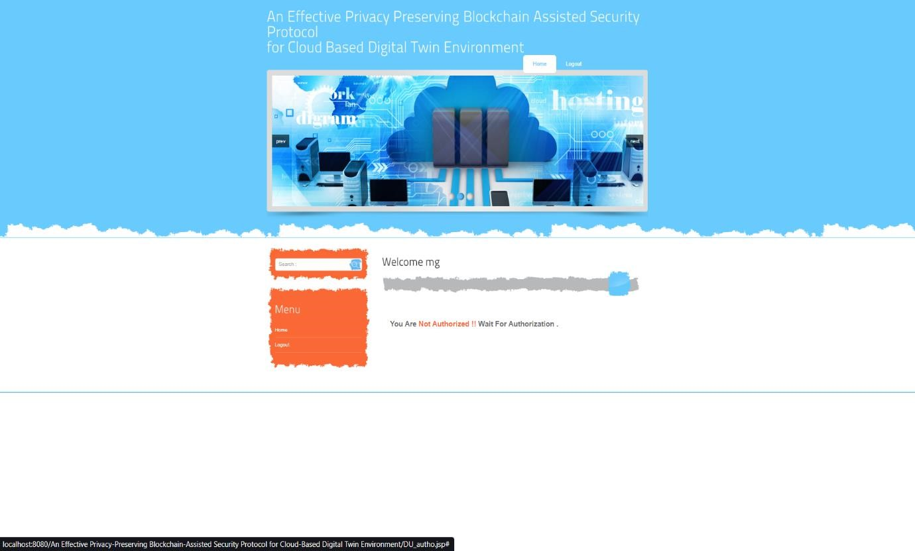

Fig 6.3: Data user login page

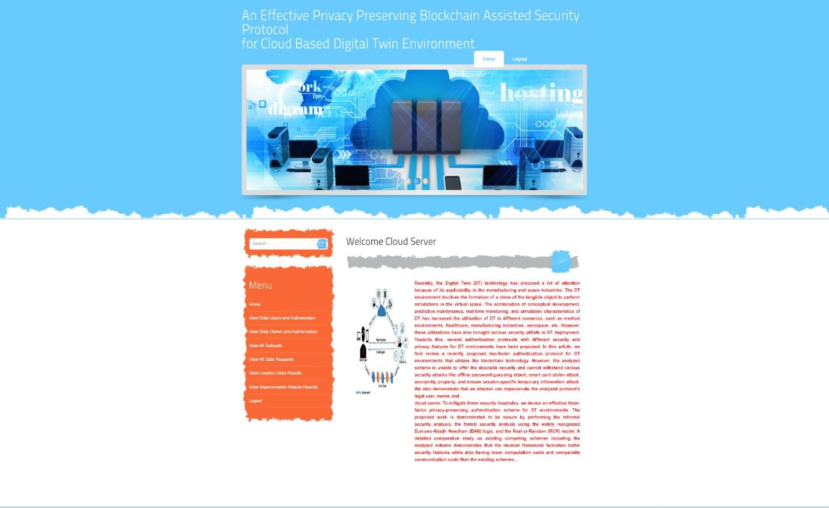

Fig 6.4: Cloud server login Page

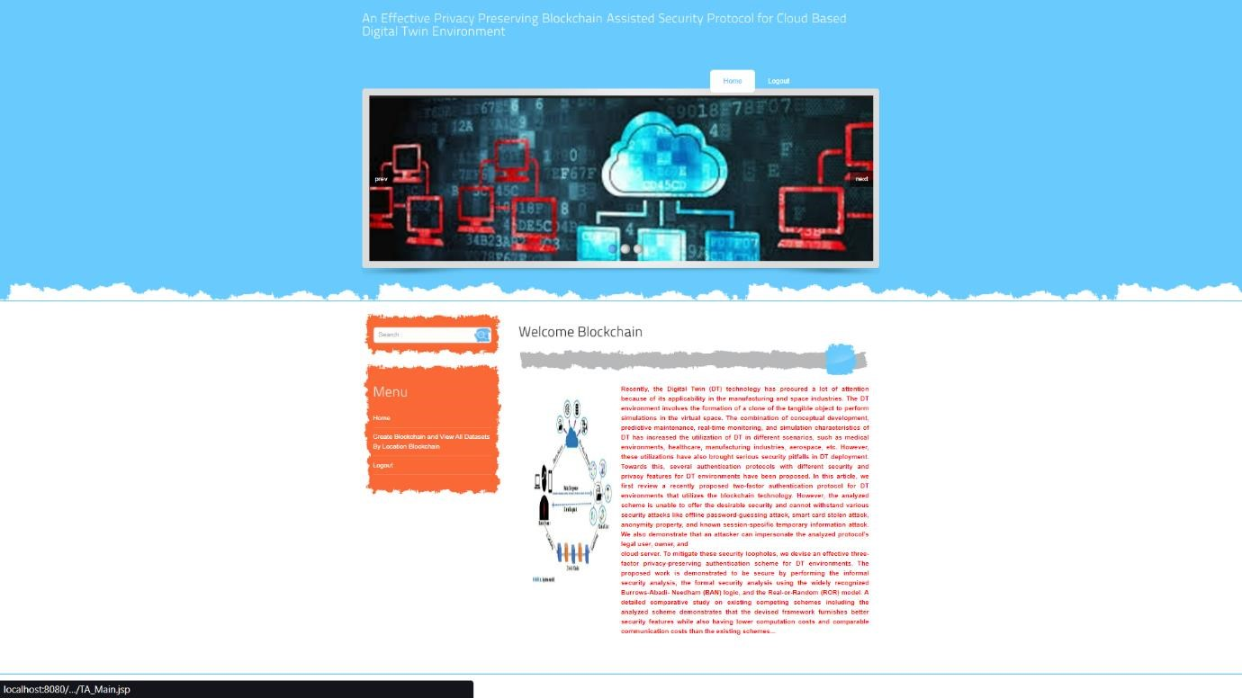

Fig 6.5: Blockchain login Page

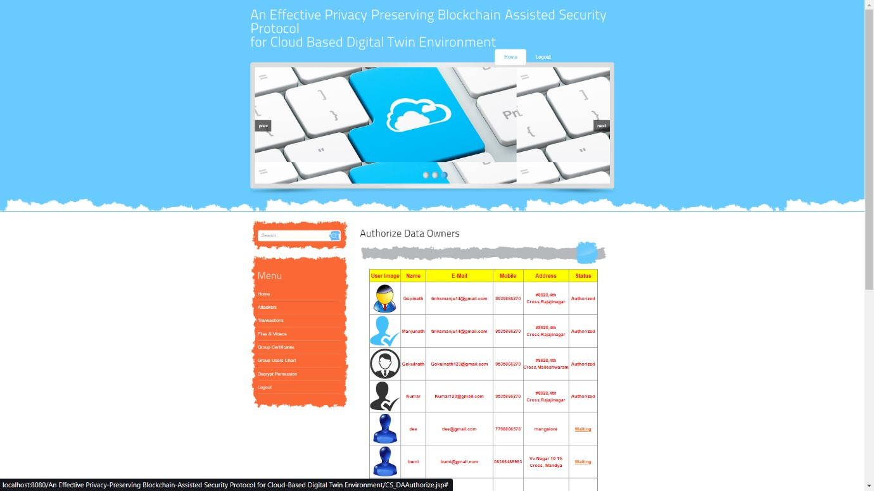

Fig 6.6: Authorize data owners Page

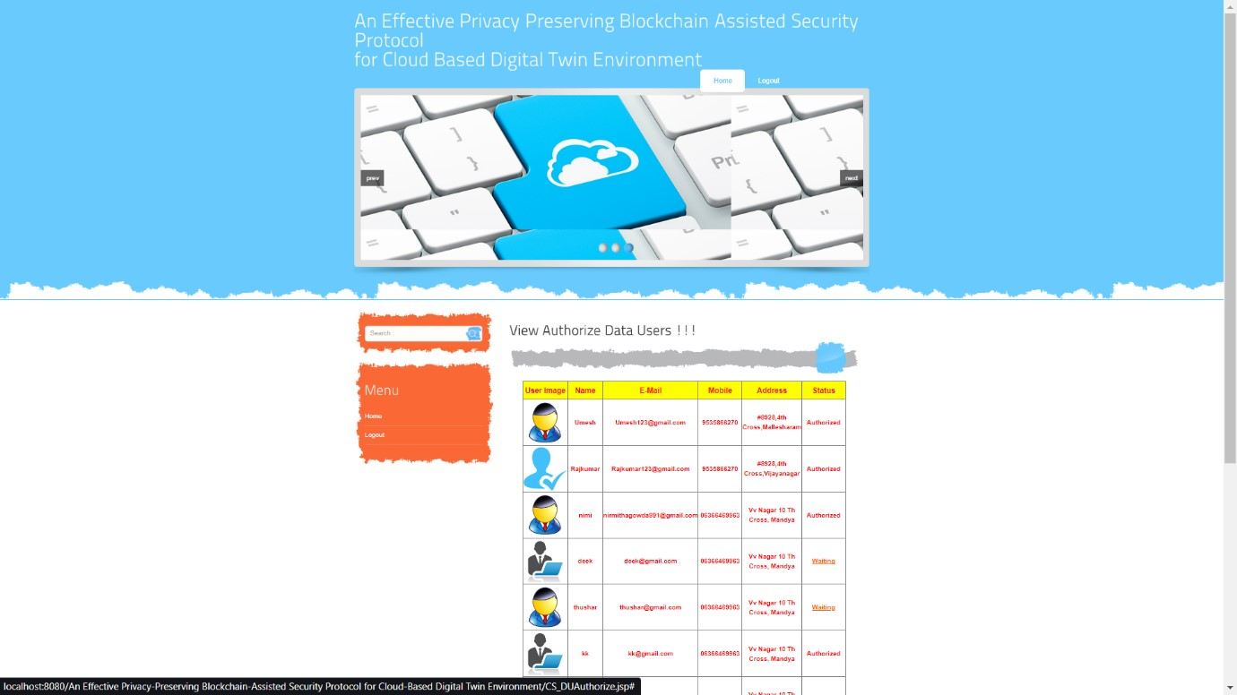

Fig 6.7: Authorize data users Page

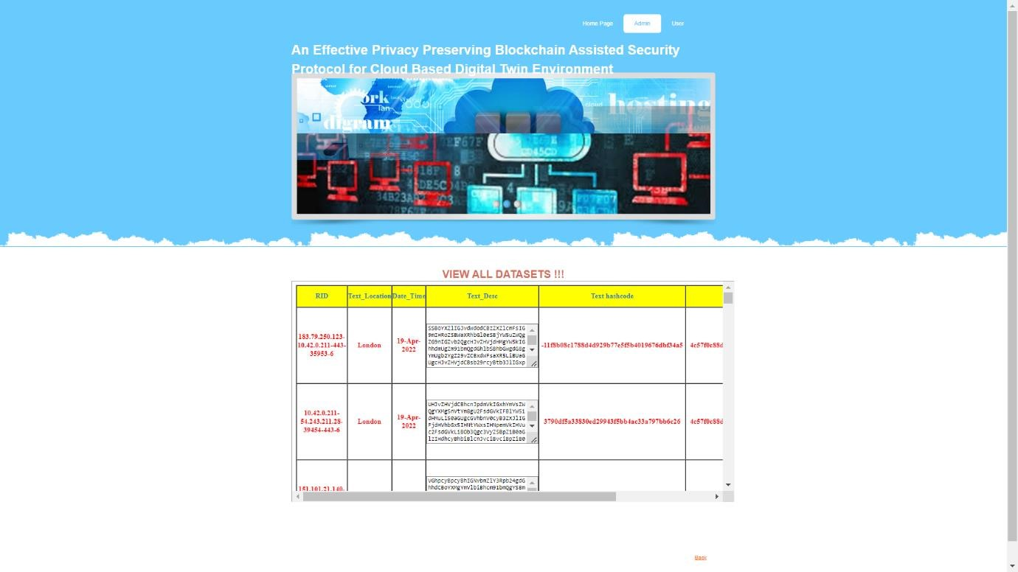
Fig 6.8: View all datasets Page

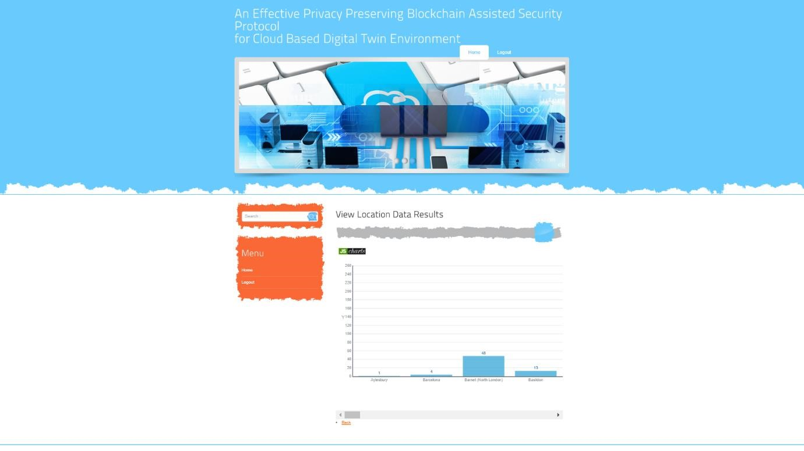

Fig 6.9: View location data results Page

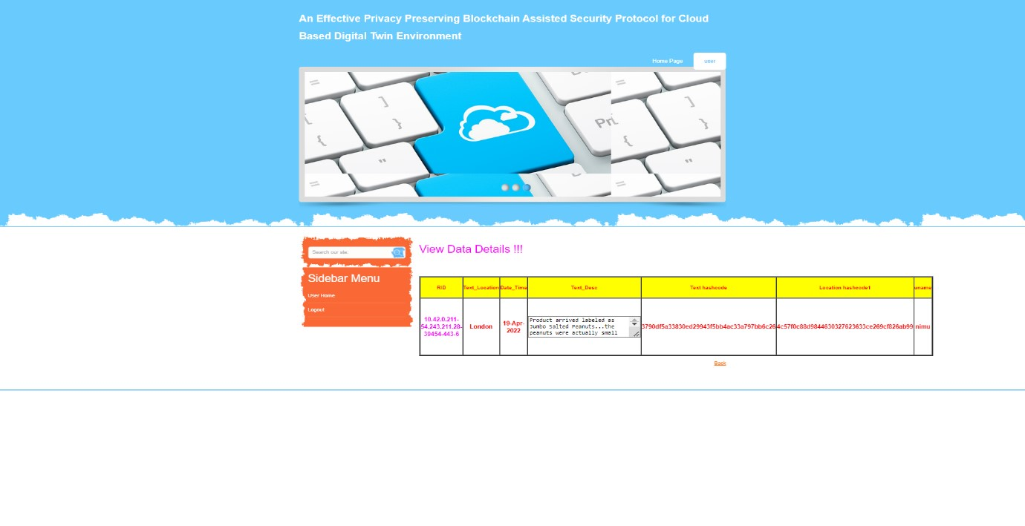

Fig 6.10: View data details Page

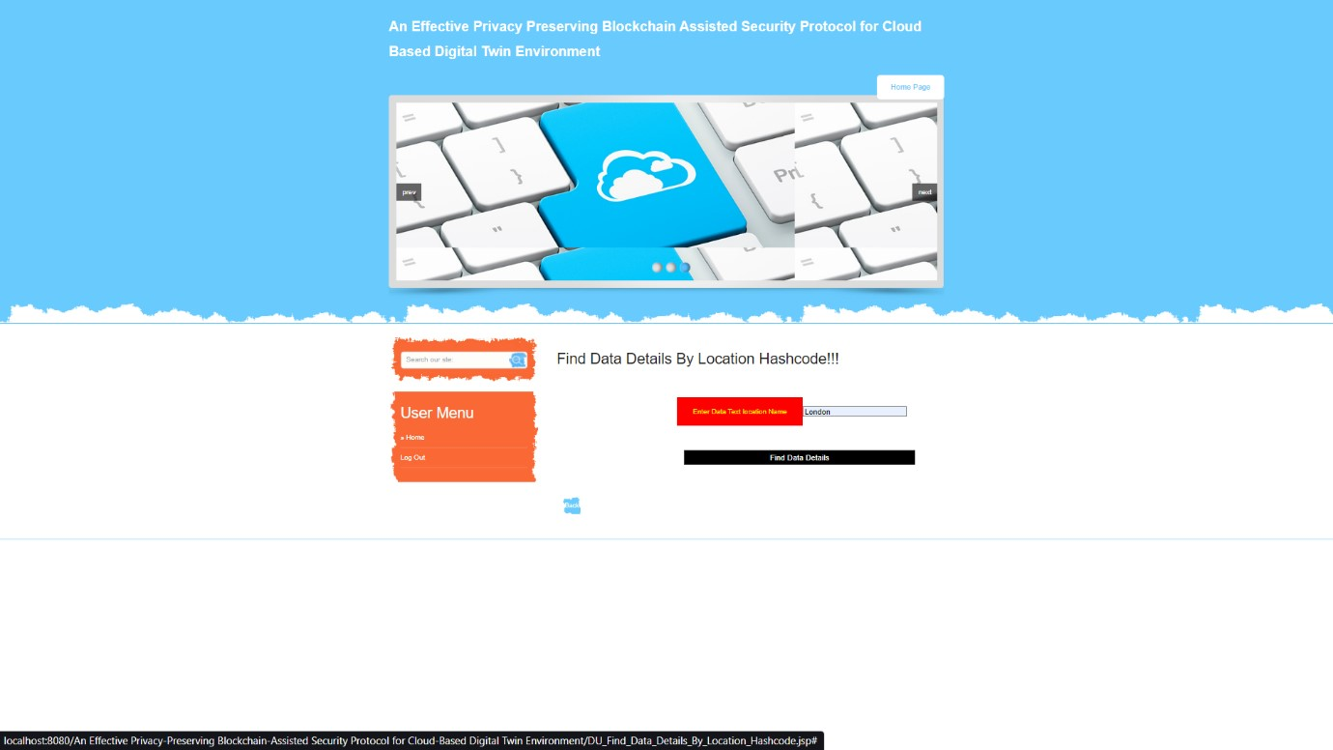

Fig 6.11: Data details by location hashcode Page

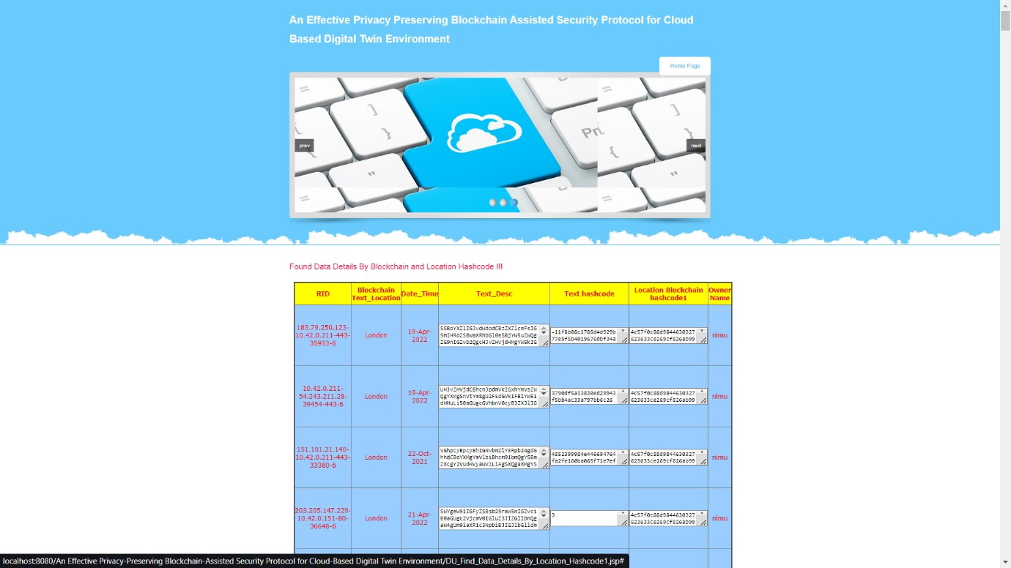

Fig 6.12: Data details by blockchain location hashcode Page

6.2 Test Cases

1. User Authentication and Authorization
- Test Case 1: Valid Login Credentials
- Description: Verify that a user can log in successfully with valid username and password.
  - Steps:
    - Enter valid username and password.
    - Click on the login button.
    - Verify that the user is logged in and redirected to the dashboard.
  - Expected Outcome: User should be logged in successfully.
- Test Case 2: Invalid Login Credentials
- Description: Verify that a user cannot log in with invalid username or password.
  - Steps:
    - Enter invalid username or password.
    - Click on the login button.
    - Verify that appropriate error message is displayed.
  - Expected Outcome: User ought not be bright to log in and should see an error message.
- Test Case 3: Access Control
- Description: Verify that user access is restricted based on roles and permissions.
  - Steps:
    - Attempt to access restricted functionalities or data.
    - Verify that unauthorized users are denied access.
    - Verify that authorized users can access the expected functionalities or data. o Expected Outcome: Access control mechanisms enforce proper role-based access.

2.Data Privacy and Security
- Test Case 4: Data Encryption
- Description: Verify that sensitive data is encrypted.
  - Steps:
    - Retrieve encrypted data from the database or storage.
    - Attempt to decrypt the data using unauthorized methods.
    - Verify that decrypted data is not accessible without proper decryption keys.
  - Expected Outcome: Encrypted data remains secure and inaccessible without proper authorization.
- Test Case 5: Anonymization Techniques
- Description: Verify that personally identifiable information (PII) is anonymized.
  - Steps:
    - Retrieve anonymized data.
    - Verify that sensitive information such as names or addresses are anonymized.
    - Attempt to reverse the anonymization process.
  - Expected Outcome: Anonymized data protects user privacy and cannot be linked back to individuals.

3. Blockchain Integration
- Test Case 6: Blockchain Transactions
- Description: Verify the accuracy and security of blockchain transactions.
o Steps:
    - Initiate a blockchain transaction (e.g., data validation, access request).
    - Verify that the transaction is recorded on the blockchain ledger.
    - Check the transaction details for accuracy and completeness.
  - Expected Outcome: Blockchain transactions are executed correctly and securely.
- Test Case 7: Smart Contract Execution
- Description: Verify the functionality of smart contracts.
o Steps:
    - Trigger a smart contract execution (e.g., access control rule, data validation).
    - Verify that the smart contract executes according to predefined rules.
    - Check for any errors or exceptions during smart contract execution.
  - Expected Outcome: Smart contracts automate processes and enforce security policies effectively.

4. Usability and User Experience
- Test Case 8: User Interface Navigation
- Description: Verify the ease of navigation and user interface responsiveness. o Steps:
    - Navigate through different sections and functionalities of the user interface.
    - Check for responsiveness on different devices (e.g., desktop, mobile).
    - Verify that links, buttons, and menus work as expected.
  - Expected Outcome: User interface is intuitive and navigation is seamless.
- Test Case 9: Error Handling
- Description: Verify the system's response to errors and exceptions.
  - Steps:
    - Introduce errors (e.g., network timeout, server error).
    - Verify that appropriate error messages or notifications are displayed.
    - Check if the system recovers gracefully from errors.
  - Expected Outcome: Users are informed of errors promptly, and the system handles errors without data loss.

CHAPTER 7

CONCLUSION

In item, we examined various design flaws and vulnerabilities ofs arrangement suggested in opposition to numerous cryptographic attacks, like user impersonation, KSSTIA, and offline password guessing attacks. By utilizing block chain technology, we proposed an enhanced three-factor-based privacy-preserving authentication framework for the DT environment. The familiar sanctuary investigation of the proposed scheme shows the efficiency and enhanced security against various wicked attacks. The mutual authentication and session key security is also ensured by performing the formal analysis of the proposed work using both the ROR Model and BAN logic. Moreover, compared to the competing existing works, the proposed method offers reduced computation costs, comparable communication costs, and superior security. Therefore, the proposed work is suitable for the DT environment. In future, we would like enhance the proposed scheme with more efficiency in terms of communication, computational and storage costs while keeping the same security level. In addition, we would also like to develop a complete test bed experiment for practical aspects of the proposed scheme.

CHAPTER 8

FUTURE ENHANCEMENT
In future enhancements of our proposed three-factor-based privacy-preserving authentication framework for Digital Twin (DT) environments, our primary objectives will focus on achieving greater efficiency across communication, computational, and storage aspects without compromising security. Building upon our informal security analysis and formal verification using models like the ROR Model and BAN logic, we aim to further fortify the framework against emerging cryptographic attacks and vulnerabilities.
Our roadmap includes optimizing cryptographic algorithms to enhance performance while maintaining robust security measures. This optimization will extend to exploring blockchain technology advancements for reducing transaction overhead and improving scalability. Additionally, implementing data compression techniques will help streamline data transmission and storage, thus optimizing bandwidth and storage utilization.
To validate these enhancements, we plan to develop a comprehensive test bed that mirrors real world DT environments. This test bed will facilitate rigorous testing under diverse conditions, ensuring the framework's reliability, scalability, and seamless integration capabilities. Moreover, we aspire to refine user interfaces and workflows to enhance user experience, leveraging user feedback to iteratively improve usability.
Overall, our future enhancements aim to cement the proposed authentication framework as a reliable, efficient, and secure solution tailored specifically for the complexities and security demands of DT environments. By focusing on these strategic improvements, we anticipate advancing the state-of-the-art in DT authentication while meeting the evolving needs of industry stakeholders and users alike.

BIBLIOGRAPHY

- M. Grieves and J. Vickers, ‘‘Digital twin: Mitigating unpredictable, undesirable emergent behavior in complex systems,’’ in Transdisciplinary Perspectives on Complex Systems: New Findings and Approaches. Cham, Switzerland: Springer, 2017, pp. 85–113.
- B. Piascik, J. Vickers, D. Lowry, S. Scotti, J. Stewart, and A. Calomino, ‘‘Materials, structures, mechanical systems, and manufacturing roadmap,’’ NASA, Washington, DC, USA, Tech. Rep. TA 12, 2012.
- H. Laaki, Y. Miche, and K. Tammi, ‘‘Prototyping a digital twin for real time remote control over mobile networks: Application of remote surgery,’’ IEEE Access, vol. 7, pp. 20325–20336, 2019.
- H. Wang and J. Zhang, ‘‘Blockchain based data integrity verification for large-scale IoT data,’’ IEEE Access, vol. 7, pp. 164996–165006, 2019.
- P. Wei, D. Wang, Y. Zhao, S. K. S. Tyagi, and N. Kumar, ‘‘Blockchain data-based cloud data integrity protection mechanism,’’ Future Gener. Comput. Syst., vol. 102, pp. 902–911, Jan. 2020.
- B. Liu, X. L. Yu, S. Chen, X. Xu, and L. Zhu, ‘‘Blockchain based data integrity service framework for IoT data,’’ in Proc. IEEE Int. Conf. Web Services (ICWS), Jun. 2017, pp. 468–475.
- S. Son, D. Kwon, J. Lee, S. Yu, N.-S. Jho, and Y. Park, ‘‘On the design of a privacypreserving communication scheme for cloud-based digital twin environments using blockchain,’’ IEEE Access, vol. 10, pp. 75365–75375, 2022.
- T.-Y. Wu, Y.-Q. Lee, C.-M. Chen, Y. Tian, and N. A. Al-Nabhan, ‘‘An enhanced pairingbased authentication scheme for smart grid communications,’’ J. Ambient Intell. Humanized Comput., vol. 2021, pp. 1–13, Jan. 2021.
- S. Khatoon, S. M. M. Rahman, M. Alrubaian, and A. Alamri, ‘‘Privacypreserved, provable secure, mutually authenticated key agreement protocol for healthcare in a smart city environment,’’ IEEE Access, vol. 7, pp. 47962–47971, 2019.
- A. Sengupta, A. Singh, P. Kumar, and T. Dhar, ‘‘A secure and improved two factor authentication scheme using elliptic curve and bilinear pairing for cyber physical systems,’’ Multimedia Tools Appl., vol. 16, pp. 1–24, Jul. 2022.
- H. S. Grover and D. Kumar, ‘‘Cryptanalysis and improvement of a threefactor user authentication scheme for smart grid environment,’’ J. Reliable
Intell. Environ., vol. 6, no. 4, pp. 249–260, Dec. 2020.
- M.Wazid, A. K. Das, N. Kumar, and J. J. P. C. Rodrigues, ‘‘Secure threefactor user authentication scheme for renewable-energy-based smart grid environment,’’ IEEE Trans. Ind. Informat., vol. 13, no. 6, pp. 3144–3153, Dec. 2017.
- D. Kaur and D. Kumar, ‘‘Cryptanalysis and improvement of a two-factor user authentication scheme for smart home,’’ J. Inf. Secur. Appl., vol. 58, May 2021, Art. no.
102787.
- M. Shuai, N. Yu, H. Wang, and L. Xiong, ‘‘Anonymous authentication scheme for smart home environment with provable security,’’ Comput. Secur., vol. 86, pp. 132–146, Sep. 2019.
- Y. Chen, J. Martinez, P. Castillejo, and L. López, ‘‘A bilinear map pairing based authentication scheme for smart grid communications: PAuth,’’ IEEE Access, vol. 7, pp.
22633–22643, 2019.
- M. Nikooghadam and H. Amintoosi, ‘‘Cryptanalysis of Khatoon et al.’s
ECC-based authentication protocol for healthcare systems,’’ 2019, arXiv:1906.08424.
- M. Abdalla, P.-A. Fouque, and D. Pointcheval, ‘‘Password-based authenticated key exchange in the three-party setting,’’ in Proc. Int. Workshop Public Key Cryptogr. Cham, Switzerland: Springer, 2005, pp. 65–84.
- M. Burrows, M. Abadi, and R. Needham, ‘‘A logic of authentication,’’ ACM Trans. Comput. Syst., vol. 8, no. 1, pp. 18–36, Feb. 1990.
- A. K. Das and B. Bruhadeshwar, ‘‘An improved and effective secure password-based authentication and key agreement scheme using smart cards for the telecare medicine information system,’’ J. Med. Syst. vol. 37, no. 5, p. 9969, 2013.
- S. Chatterjee and A. K. Das, ‘‘An effective ECC-based user access control scheme with attribute-based encryption for wireless sensor networks,’’ Secur. Commun. Netw., vol. 8, no. 9, pp. 1752–1771, 2015.
- D. Mishra, A. K. Das, and S. Mukhopadhyay, ‘‘A secure and efficient ECC-based user anonymity-preserving session initiation authentication protocol using smart card,’’ Peer-Peer Netw. Appl., vol. 9, no. 1, pp. 171–192, Jan. 2016. [22] S. Mandal, B. Bera, A. K. Sutrala, A. K. Das, K. R. Choo, and Y. Park, ‘‘Certificatelesssigncryption-based three-factor user access control scheme for IoT environment,’’ IEEE Internet Things J., vol. 7, no. 4, pp. 3184–3197, Apr. 2020.
[23] M. Wazid, S. Thapliyal, D. P. Singh, A. K. Das, and S. Shetty, ‘‘Design and testbed experiments of user authentication and key establishment

